How does weather impact sales of the products?

- Product 3:
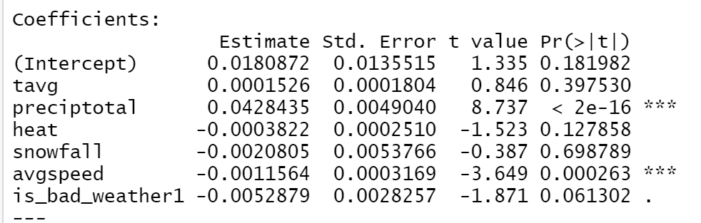
Precipitation Total(preciptotal) has the strongest influence on sales. The result estimates for 1 unit increase in total precipitation, there is expected 0.0428435 more units sold, all else equal. Hence, it is a positive relationship.

- Product 15:
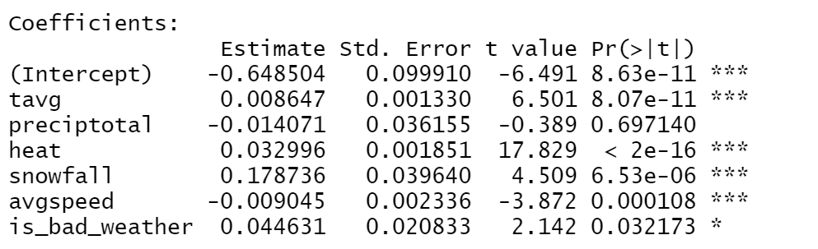
Snowfall has the strongest influence on sales. The result estimates for 1 unit increase in snowfall, there is expected 0.178736 more units sold, all else equal. Hence, it is a positive relationship.

- Product 28:
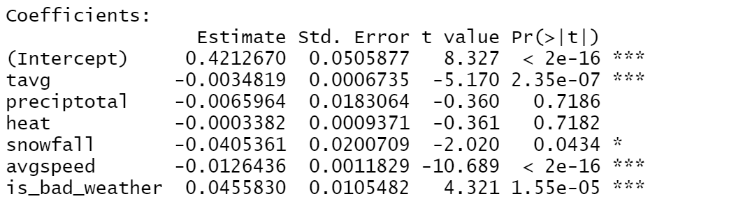
Whether is bad weather(is_bad_weather) has the strongest influence on sales. The result estimates for 1 unit increase in is_bad_weather(switching from 0 to 1), there is expected 0.0455830 more units sold, all else equal. Hence, it is a positive relationship.

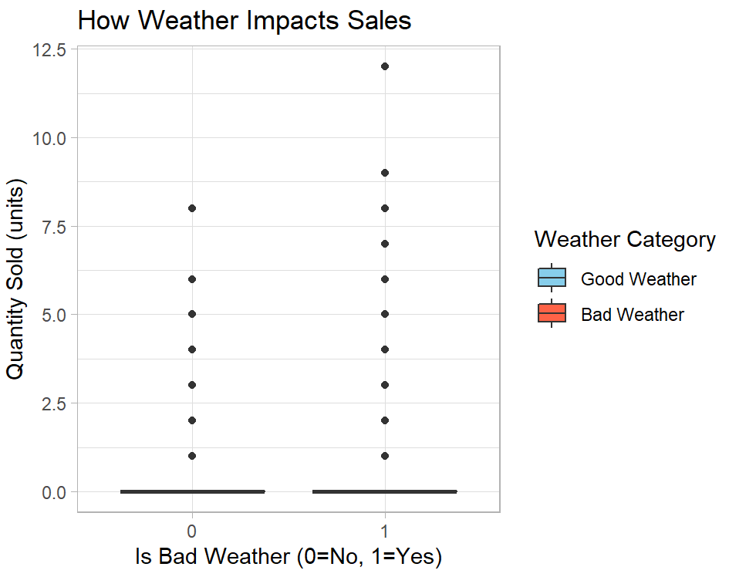
On the boxplot, it shows that the most data are zero.
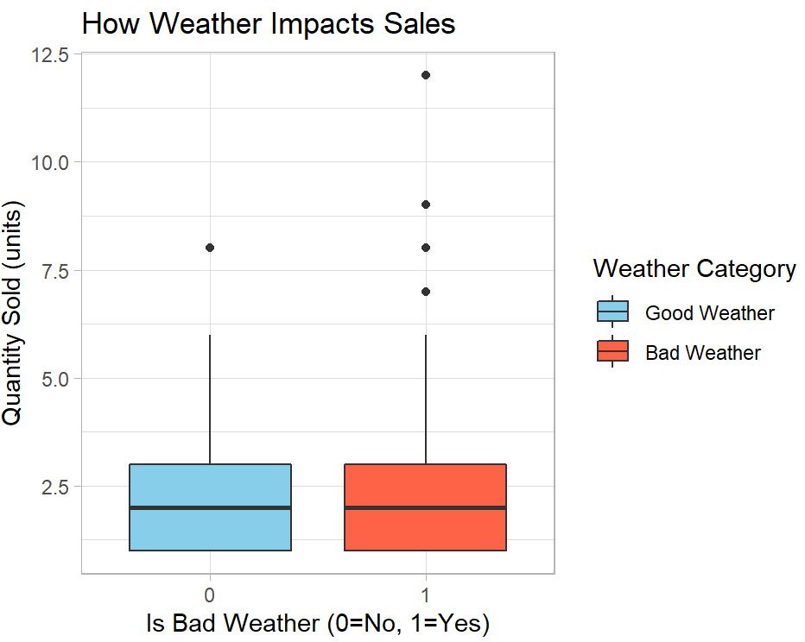
After filtering the zero, the box plot shows that the Q1, median, and Q3 are similar while Bad Weather has a higher maximum value on quantity sold.
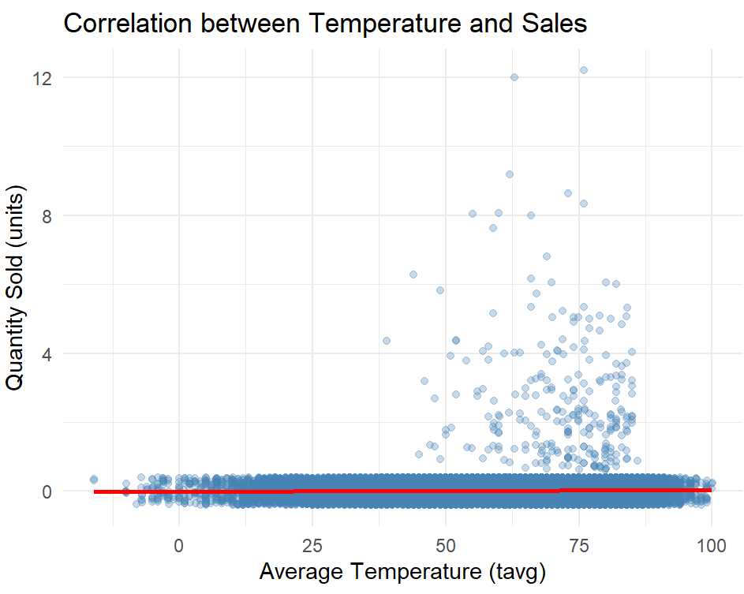
On the scatter plot, it shows that there are more sales if the average temperature is between 50 to 80 degrees Fahrenheit.

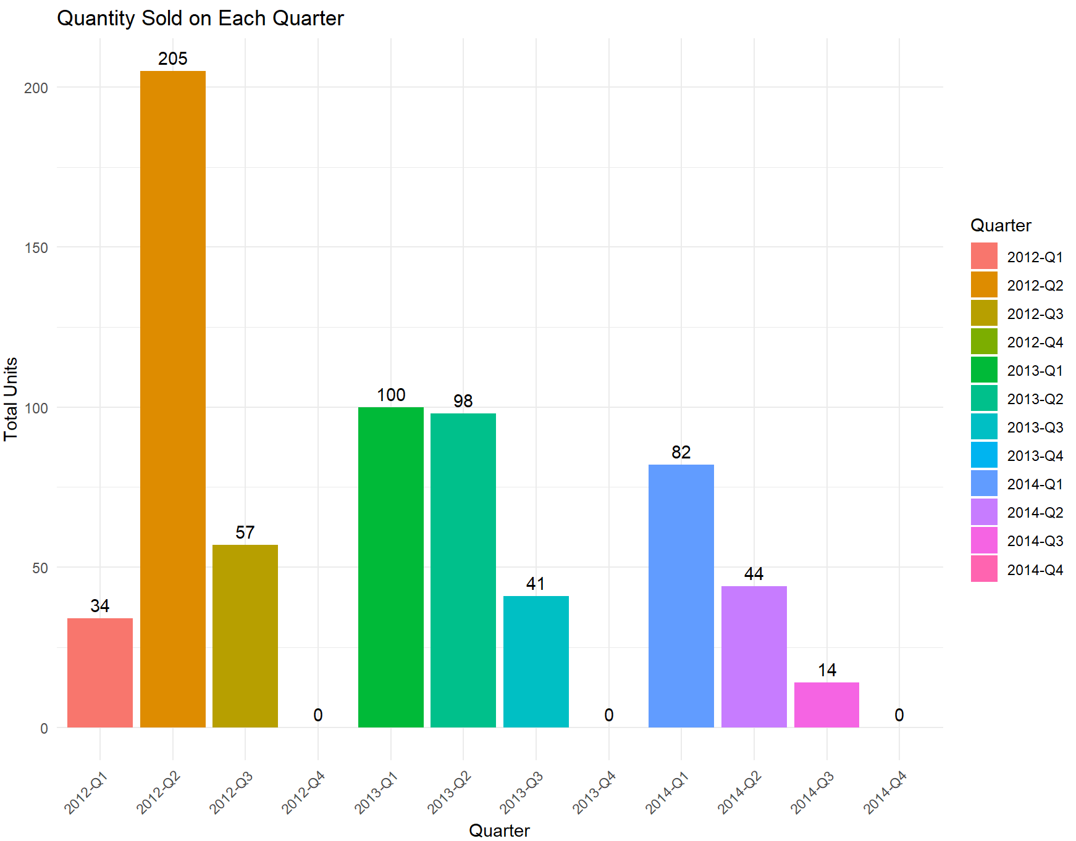
The bar chart shows that 2012 Q2 has the highest sales. The sales of product 3 is declining from 2012 to 2014.

Business Recommendations:
- According to the scatterplot, it shows that there are more sales if the average temperature is between 50 to 80 degrees Fahrenheit. Therefore, the company could increase stock of Product 3 when the temperature is between 50 to 80 degrees Fahrenheit.
- The company could increase the stock for Product 15 when there is snowfall as there is a positive relationship between snowfall and quantity sold using linear regression.
- When there is bad weather, we could increase the stock for Product 28 since according to the linear regression, there is expected 0.0455830 more units sold (other factors remain constant).

